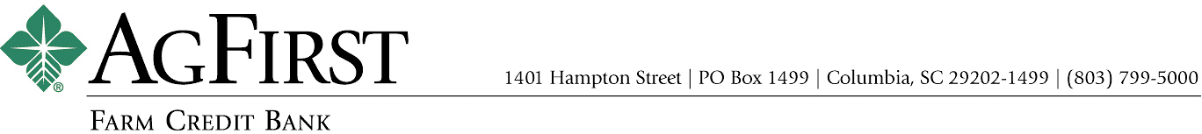

NEWS RELEASE Contacts:
Donna J. Camacho, Director of Communications
dcamacho@agfirst.com; 803-753-2251
Joy M. Upchurch, Vice President-Marketing
jupchurch@agfirst.com; 803-753-3379

for release
Tuesday, November 25, 2002

AgFirst Reports Third Quarter Earnings
Columbia, S.C. —AgFirst Farm Credit Bank today reported net income of $143.4 million for the nine months ended September 30, 2002, a 67 percent increase compared to the same period last year. For the three months ended September 30, 2002, net income was $48.8 million, an increase $19.9 million or 69 percent compared to the same period last year. Growth in loan volume and lower debt costs contributed to the increase in net income.
“We’re enjoying another record-setting year,” said AgFirst CEO F. A. (Andy) Lowrey. “We have been able to achieve lower funding costs by exercising call options on our bonds,” continued Lowrey, “and, our affiliated retail lenders have grown more than 12 percent compared to a year ago.”
AgFirst’s affiliated retail lenders finance farmers, agribusinesses and rural homeowners in fifteen eastern states and Puerto Rico. Their retail volume is funded through a direct note payable to AgFirst. “The growth in our retail lending can be attributed to several factors, including less competition from commercial banks and the growing favor with which borrowers view our associations’ patronage dividends,” said Lowrey. Since 1989, lenders affiliated with AgFirst have paid patronage refunds of more than $1.5 billion to their borrowers.
In addition to its retail business, AgFirst operates a Capital Markets Unit, which arranges and participates in loans for agribusinesses, as well as a Secondary Mortgage Market Unit, which buys, sells and services agricultural and rural home loans throughout the United States. “Our Secondary Mortgage Market is continuing to grow,” noted Lowrey. “As of September 30, 2002, we were servicing $1.14 billion in loans, as compared to $783 million at the same time last year,” he remarked.

AgFirst Reports Third Quarter Earnings 2

AgFirst is part of the nationwide Farm Credit System, the largest agricultural lending organization in the United States. The bank provides funding and financial services to 24 farmer-owned financial cooperatives called Agricultural Credit Associations (ACAs). These ACAs provide real estate and production financing to more than 80,000 farmers, agribusinesses and rural homeowners.
On a combined basis, the Farm Credit System reported assets of $107 billion on September 30, 2002, as compared to $101 billion on December 31, 2001. The System’s combined net income for the nine months ended September 30, 2002, was $1.37 billion, as compared to $1.29 billion the same period last year.
###

Note: AgFirst CEO Andy Lowrey is available for interviews. To schedule an interview, please call Donna Camacho, Director of Advertising and Communications, at 803-753-2251, or email her at dcamacho@agfirst.com. Additional information is available at www.agfirst.com.

AgFirst Reports Third Quarter Earnings 3

